**Project Report**

*on*

Movie Ticketing Bot Powered

by IBM Watson Assistant

**TABLE OF CONTENT**

|  |  |
| --- | --- |
| **1 . INTRODUCTION** | **1** |
| **2. THEORITICAL ANALYSIS** | **1** |
| **3. FLOWCHART** | **2** |
| **4. RESULT** | **3** |
| **5.** **ADVANTAGES AND DISADVANTAGES** | **6** |
| **6. APPLICATION** | **6** |
| **7 . CONCLUSION** | **7** |
| **8. Future Scope** | **7** |
| **9. BIBLOGRAPHY** | **8** |

**1 . INTRODUCTION 1**

1.1 overview

In this project, we will be building a chatbot using Watson assistant. This chat should have the following capabilities

* Give the list of movies available
* The Bot should be able to show different show timings
* When a movie is selected the bot should show the availability of tickets and their respective prices.
* The bot should be in a position to book tickets.

1.2 Purpose

This work aims to provide a fast and convenient way to manage our ticket booking. The online movie ticket booking chatbot will help facilitate the user by booking ticket according to there selected region .

**2. THEORITICAL ANALYSIS**

2.1 *Block Diagram*

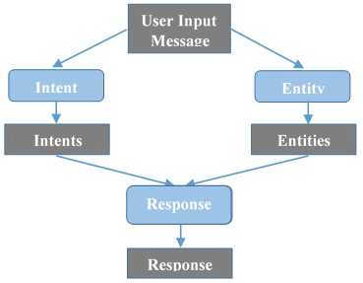

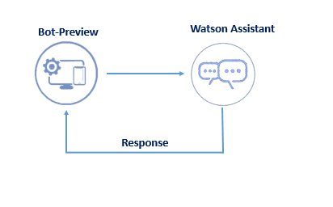 2

2.2 *Services used*

1. IBM Watson Assistant
2. Node-Red

**3. FLOWCHART**

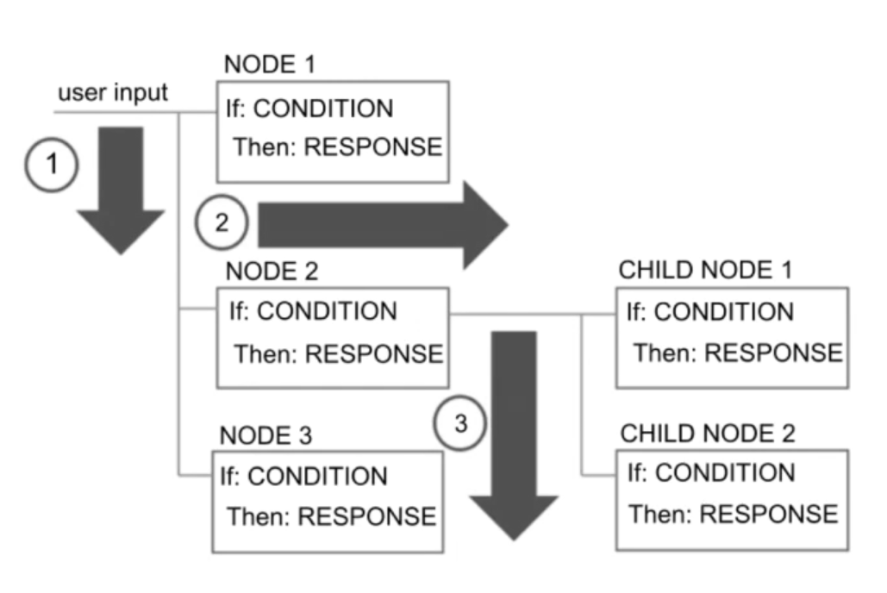

**4. RESULT 3**

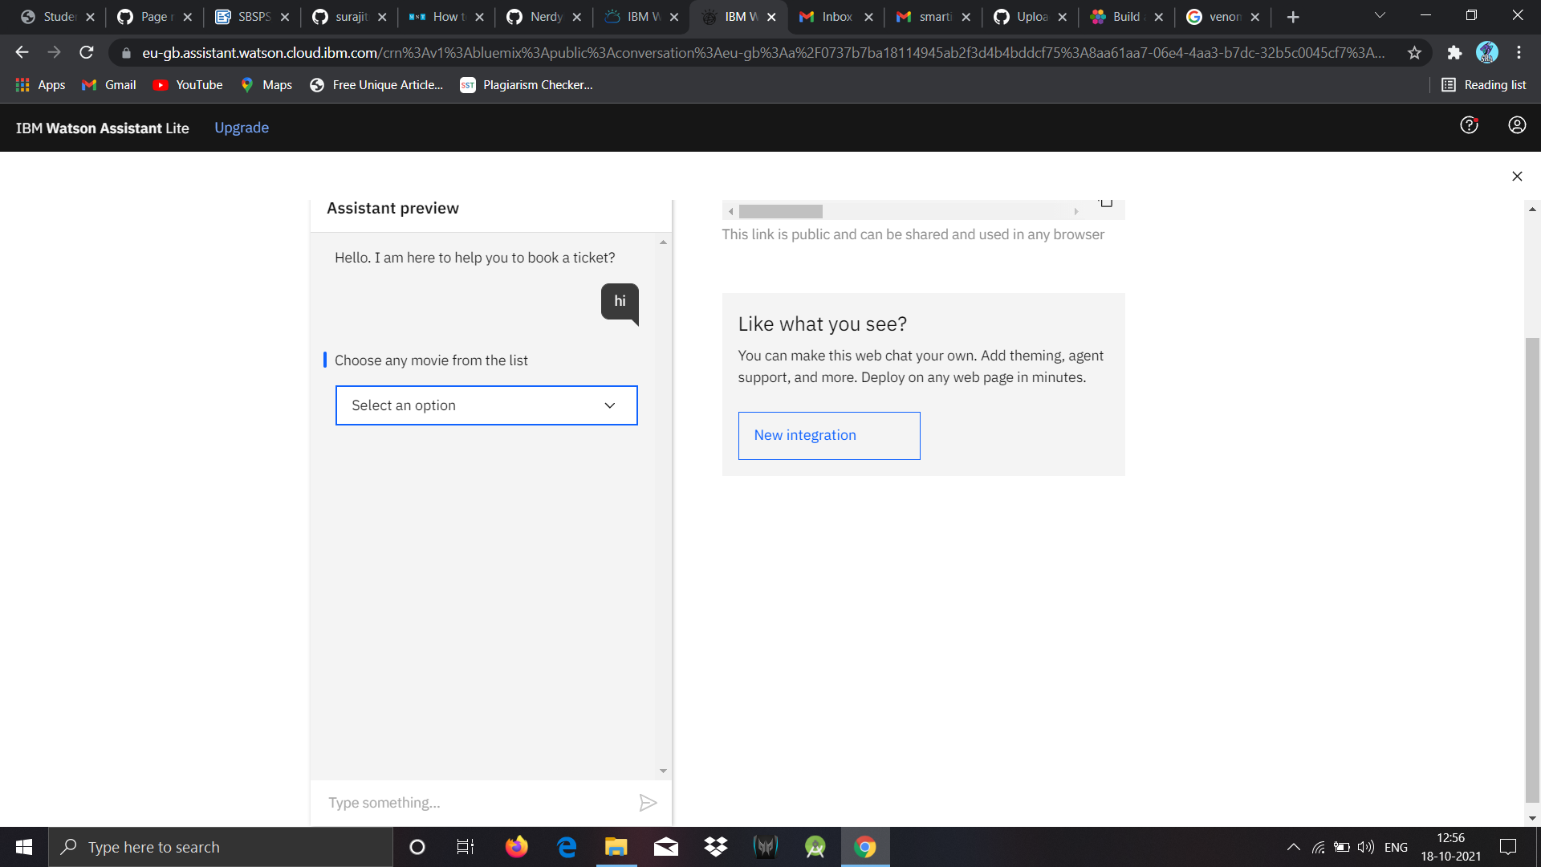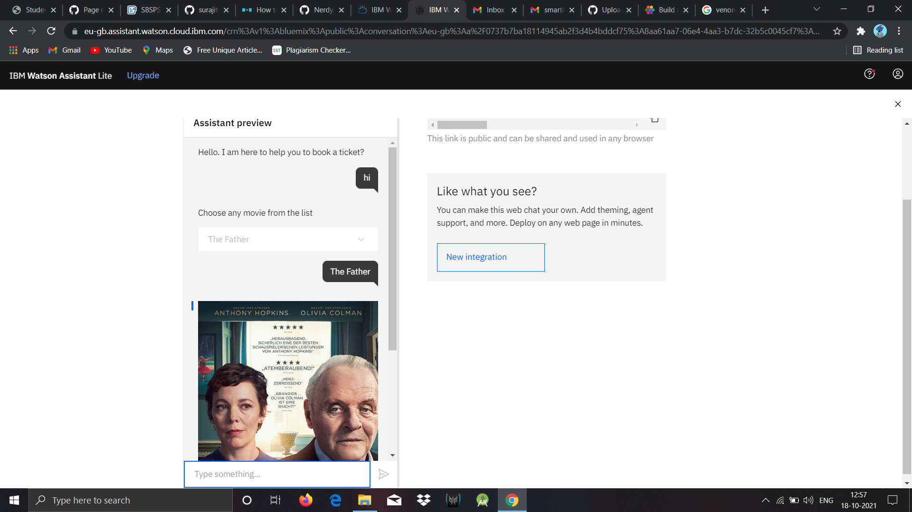

4

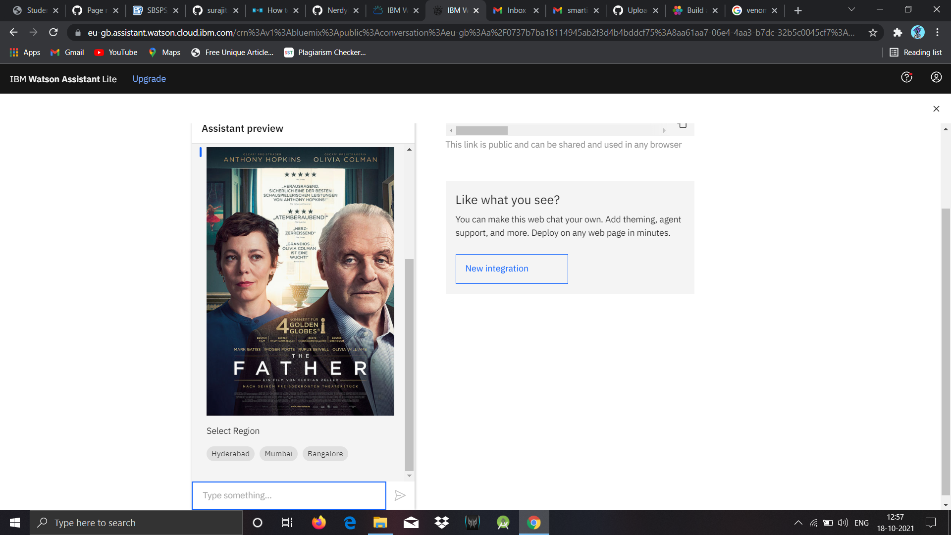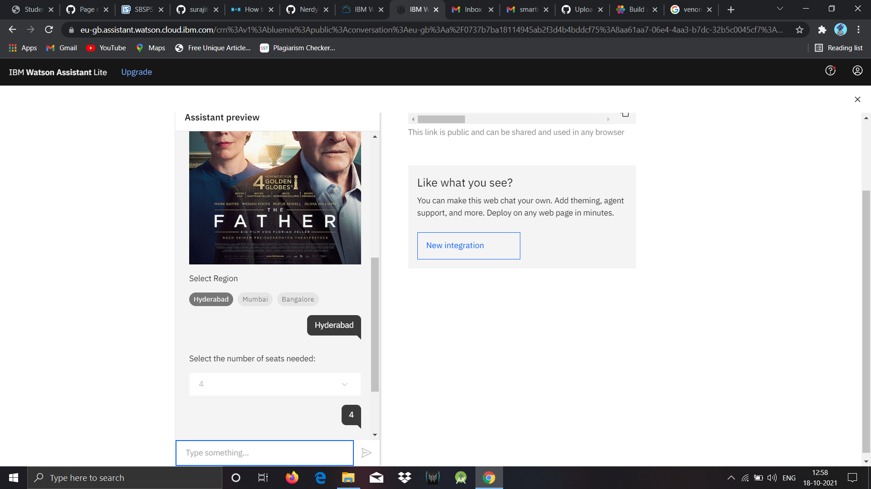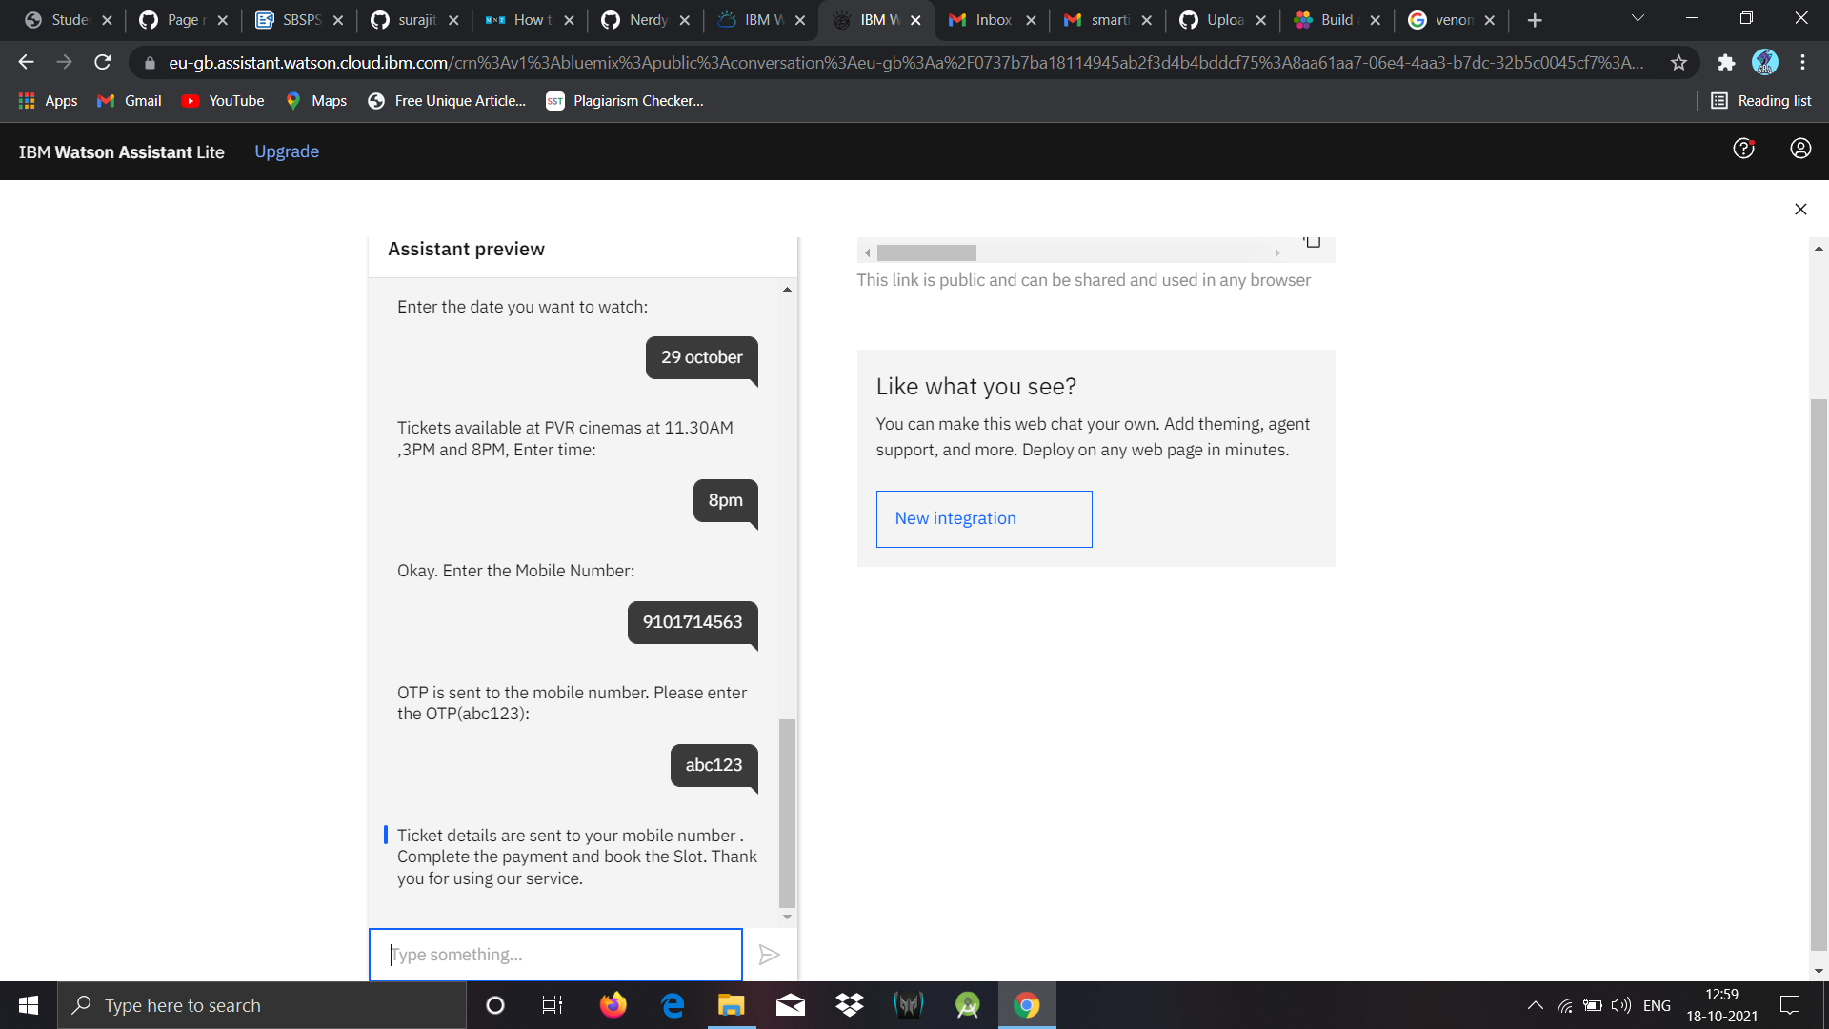

5

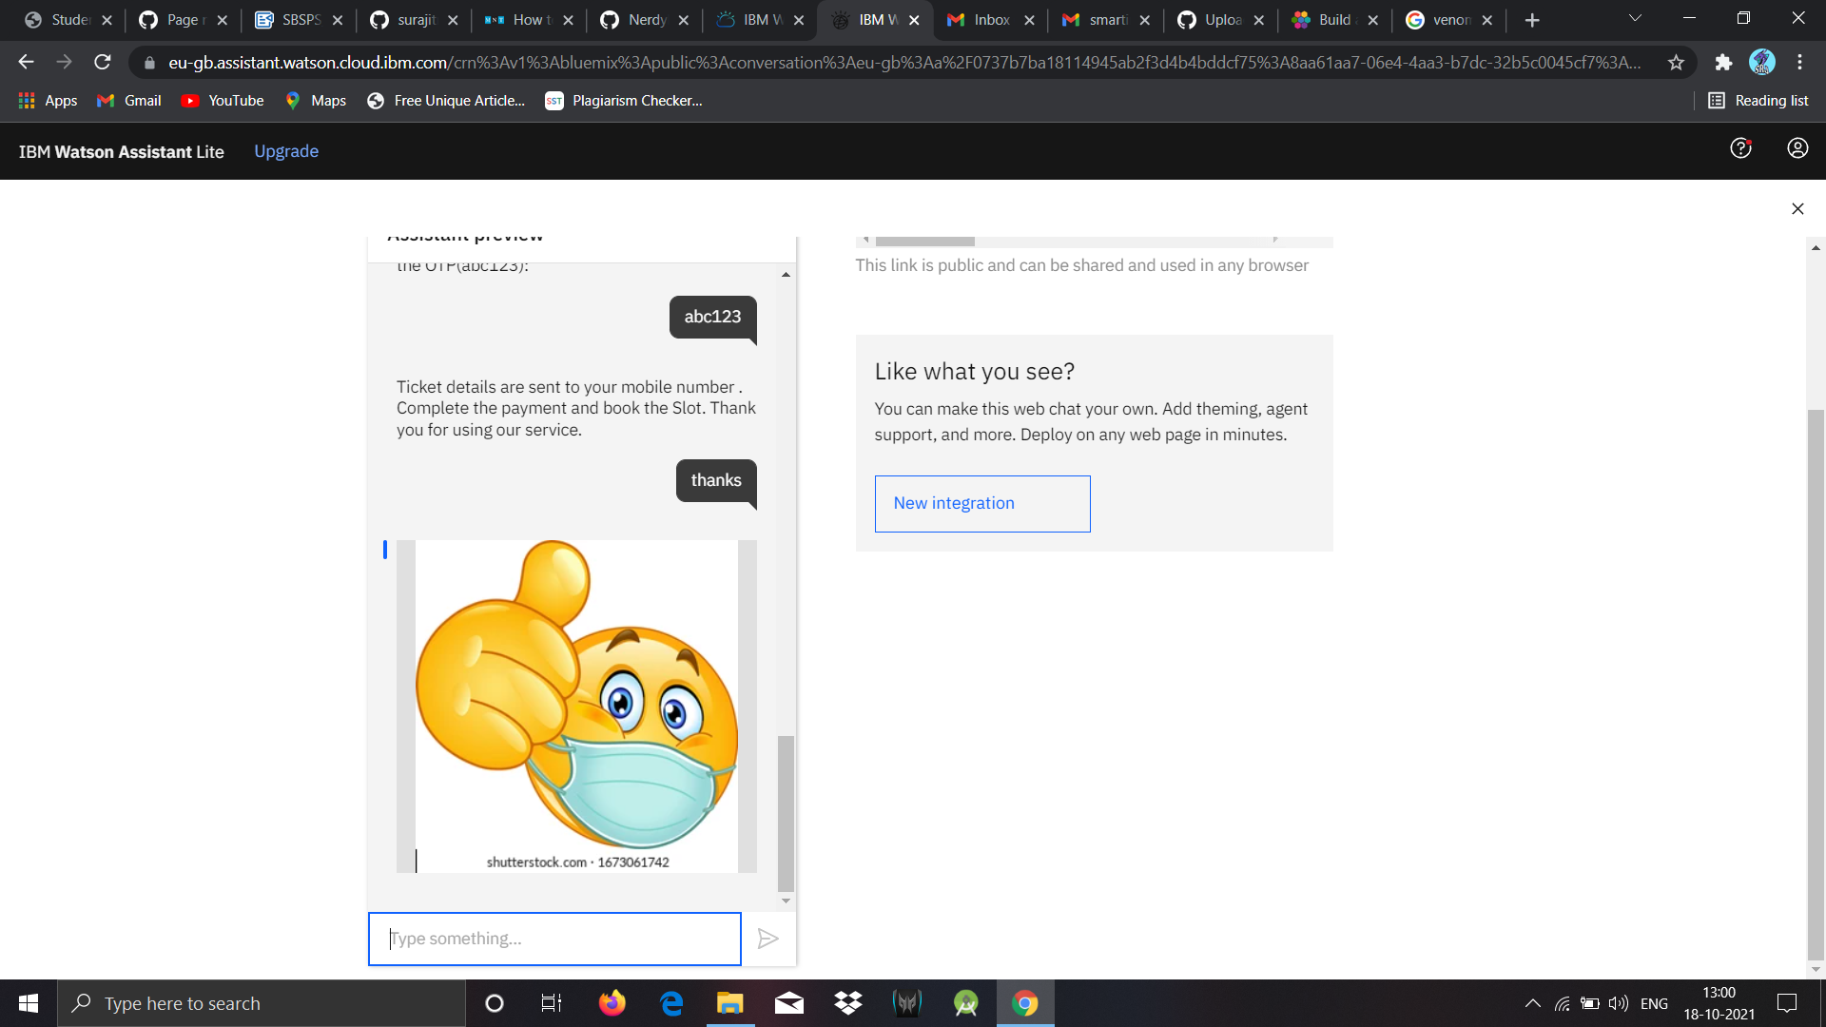

**5.** **ADVANTAGES AND DISADVANTAGES**

6

*Advantages:*

* **They help you get to know your customers**
* **They're a selling machine**
* **Customer service at any time**
* **They help optimize costs**
* **They improve customer satisfaction**

*Disadvantages:*

* **A bot is not a person**
* **You need time for implementation**
* **They need maintenance**

**6. APPLICATION**

* Retail and e-commerce
* Travel and hospitality
* Banking, finance, and fintech
* Healthcare
* Media and entertainment
* Education

**7 . CONCLUSION**

7

From my perspective, chatbots or smart assistants with artificial intelligence are dramatically changing businesses. There is a wide range of chatbot building platforms that are available for various enterprises, such as e-commerce, retail, banking, leisure, travel, healthcare, and so on.

Chatbots can reach out to a large audience on messaging apps and be more effective than humans. They may develop into a capable information-gathering tool in the near future.

**8. Future Scope**

Chatbots are fully functioning, semi-autonomous systems that can assist customer service experiences and response time. But that doesn't mean their future in the enterprise is secure. For [chatbots](https://searchcustomerexperience.techtarget.com/definition/chatbot) to withstand the rapidly increasing technological shifts and become mainstays in the enterprise, developers need to examine the issues that have popped up with increased implementation.

The future scope of chatbots could include many benefits for enterprises, but experts say they will need to be gently nudged in the right direction for businesses to reap these benefits.

**9. BIBLOGRAPHY**

8

WEBSITE

Ibm cloud = [https://cloud.ibm.com/,](mailto:https://cloud.ibm.com/) Ibm Watson= [https://cloud.ibm.com/catalog/services/watson-assistant](https://cloud.ibm.com/catalog/services/watson-assistant%20) ,

**APPENDIX**

***PREVIEW LINK:-***[*https://web-chat.global.assistant.watson.cloud.ibm.com/preview.html?region=eu-gb&integrationID=1b71a886-a6df-4d8e-b579-53c26702ef3c&serviceInstanceID=8aa61aa7-06e4-4aa3-b7dc-32b5c0045cf7*](https://web-chat.global.assistant.watson.cloud.ibm.com/preview.html?region=eu-gb&integrationID=1b71a886-a6df-4d8e-b579-53c26702ef3c&serviceInstanceID=8aa61aa7-06e4-4aa3-b7dc-32b5c0045cf7)

***Use default OTP :- abc123***

***SOURCE CODE:-***

